# Cause and Effect Analysis

## Group Members

* 103428- Fredah Kioko
* 111878-Lilian Thairu
* 110785-Lydia Kahuria

# The fish bone diagram below shows the causes of poor quality of the goods

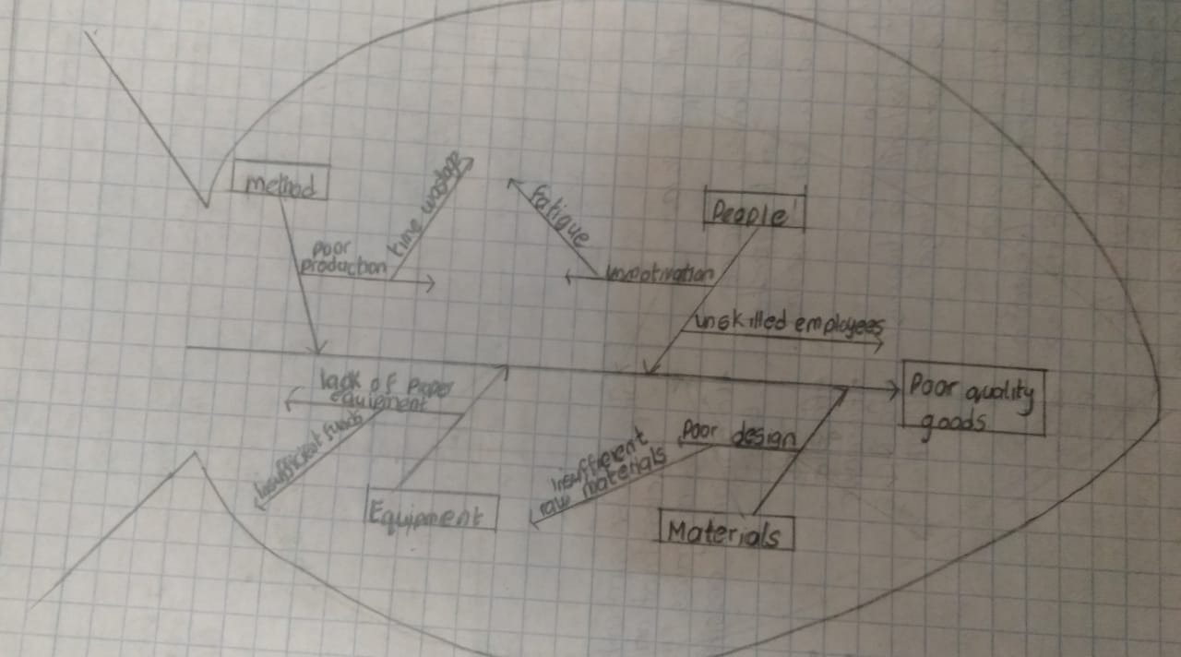

Here are the categories:

* People

The employees maybe unskilled in the work and may require training. Furthermore, fatigue from transporting the goods leads to lack of motivation.

* Method

Poor production of the items may occur and this is as a result of time wasted on transporting the goods to the consumers.

* Equipment

The proper equipment necessary in the creation of the goods may be insufficient due to lack of finances as the finances were used in transporting the goods.

* Materials

The deign of the goods may be poor due to insufficient raw materials such as the beads.